CUSTOMER SEGMENTATION USING K-MEAN, DENSITY AND CENTROID BASED CLUSTERING IN MACHINE LEARNING

A PROJECT REPORT

Submitted by
ANWAR HAMEED. G (191421601004)
&
NATHIPRIYA. V (191421601036)

Under the guidance of
Mrs. Preethi Verma

In the partial fulfilment for the award of the degree of
Bachelor of Computer Applications
in
DATA SCIENCE

JUNE 2022
www.crescent.education

BONAFIDE CERTIFICATE
Certified that this project report “CUSTOMER SEGMENTATION USING K-MEAN, DENSIYTY AND CENTROID BASED CLUSTERING IN MACHINE LEARNING ” is the bonafide work of ANWAR HAMEED. G (191421601004) and NATHIPRIYA. V (191421601036) who carried out the project under my supervision. Certified further, that to the best of my knowledge the work reported herein does not from part of any other project report or dissertation on the basis of which a degree or award was conferred on an earlier occasion on this or any other candidate.
SIGNATURE SIGNATURE

Mrs. Preethi Verma Dr. S. PAKKIR MOHIDEEN
Supervisor Head of the Department
Assistant Professor Associate Professor and Head
Department of Computer Applications Department of Computer Applications
B.S. Abdur Rahman Crescent Institute of B.S. Abdur Rahman Crescent Institute of
Science and Technology, Seethakathi Science and Technology, Seethakathi
Estate Vandalur, Chennai -634048. Estate, Vandalur, Chennai-634048.

VIVA-VOCE EXAMINATION

The viva-voce examination of the project work titled “CUSTOMER SEGMENTATION USING K-MEAN DENSITY AND CENTROID BASED CLUSTERING IN MACHINE LEARNING” submitted by ANWAR HAMEED. G (191421601004) and NATHIPRIYA. V (191421601036), is held on ____________________

INTERNAL EXAMINER EXTERNAL EXAMINER

ACKNOWLEDGEMENT

We thank the Almighty for showering His blessings upon us in completing the project. I submit this project with a deep sense of gratitude and reverence for my beloved parents for their moral support and encouragements.

We sincerely express our heartfelt gratitude to Dr. A. Peer Mohamed
Vice Chancellor, B.S. Abdur Rahman Crescent Institute of Science and Technology and Dr. A. Azad, Registrar, for furnishing every essential facility for doing my project.
We owe our sincere gratitude to Dr. Venkatesan Selvam, Professor and Dean, School of Computer, Information and Mathematical Science (SCIMS). Dr. S. Pakkir Mohideen, Professor and Head, Department of Computer Applications, for providing strong oversight of vision, strategic direction, encouragement and valuable suggestions in completing my project work.
We convey our earnest thanks to our project guide Mrs. Preethi Verma, Assistant Professor, Department of Computer Applications, for her valuable guidance and support throughout the project.
We express our gratitude to the Project Coordinators, Dr. R. Thilagavathy, Assistant Professor and Dr. V. Shenbagapriya, Assistant Professor and other project Committee Members of the Department of Computer Applications for their support and continued assistance in the process.
We extend our sincere thanks to all our faculty members for their valuable suggestions, timely advice and support to complete the project.
ANWAR HAMEED G
NATHIPRIYA V

ABSTRACT

Customer segmentation of shopping malls is a way of segmenting customers into a group of segments based on the similarity of the customers and their tastes and purchase history. As the number of entrepreneurs and businesses increases there is a huge competition in the market. In such case customer segmentation is a better option to increase the sales and customer service. Segmentation allows businesses to make a better use of their marketing budgets. And the ability of understanding the demands of the customer increases the customer support. In the proposed model, customer segmentation is done using machine learning. Hybrid of k-means, density and centroid based clustering algorithm is the convenient algorithm for customer segmentation. The data of the purchase history and customer details is the basic dataset for the customer segmentation of shopping malls.

TABLE OF CONTENTS
Chapter TITLE PAGE NO.
NO.
ABSTRACT v
LIST OF FIGURES ix
LIST OF TABLES x
LIST OF ABBREVATION x

1 INTRODUCTION 11
1.1 GENERAL 11
1.2 EXISTING SYSTEM 11
1.2.1 LITERATURE SURVEY 12
1.2.2 DISADVANTAGE OF EXISTING SYSTEM 16
1.3 PROPOSED SYSTEM 16
1.3.1 ADVANTAGES 17
1.4 ORGANISATION OF CHAPTERS 17
2 PROBLEM DEFINITION AND METHODOLOGY 18
2.1 PROBLEM DEFINITION 18
2.2 METHODOLOGY 18
2.2.1 ELBOW METHOD 19
2.3 DISCUSSION OF ALGORITHM 19
2 .3.1 K-MEANS ALGORITHM 19
3 DEVELOPMENT PROCESS 20
3.1 REQUIREMENT ANALYSIS 20
3.1.1 INPUT REQUIREMENTS 20
3.1.2 OUPUT REQUIREMENTS 20
3.2 RESOURCE REQUIREMENTS 20
3.2.1 SYSTEM REQUIREMENT 21
3.3 SYSTEM DESIGN 21
3.3.1 USE CASE DIAGRAM 22
3.3.2 ARCHITECTURE DIAGRAM 23
3.5 IMPLEMENTATION 29
3.6 TESTING 31
3.7 TEST CASE 32
3.8 MODULES 34
3.8.1 Pyttsx3 34
3.8.2 SPEECH RECOGNITION 35
3.8.3 PYAUDIO 35
3.8.4 DICTIONARY 35
3.8.5 TKINTER 36

4 RESULTS AND DISCUSSION 37
4.1 RESULTS 37
4.2 DISCUSSION 37

5 CONCLUSION AND FUTURE ENHANCEMENT 42
5.1 CONCLUSION 42
5.2 FUTURE WORK 42

APPENDICES: SAMPLE CODE 43
REFERENCES 48
TECHNICAL BIOGRAPHY 49

LIST OF FIGURES
FIGURE TITLE PAGE NO.
NO.
3.1 USE CASE DIAGRAM 22
3.2 ARCHITECTURE DIAGRAM 23
3.3 FLOW CHART 24
3.4 CLASS DIAGRAM 25
3.5 SEQUENCE DIAGRAM 26
3.6 DATA FLOW DIAGRAM – LEVEL 0 27
3.7 DATA FLOW DIAGRAM – LEVEL 1 28
3.8 IMPLEMENTATION OF MODULES 29
3.9 INTERFACE 30
4.1 OUTPUT FOR MEANING 38
4.2 OUTPUT FOR ANTONYM 30
4.3 OUTPUT FOR PRONUNCIATION 40
4.4 OUT FOR WORD NOT FOUND 41

TABLES
TABLE TITLE PAGE NO.
NO.
3.1 TEST CASE 33

LIST OF ABBREVIATION

Pyttsx3 – PYTHON TEXT TO SPEECH VERSION 3

CHAPTER 1

INTRODUCTION

This chapter deals with the general introduction of the project, existing system and the proposed system for this project. Existing system elucidates the current system and its limitations and proposed system provides a solution to overcome those limitations.

1.1 GENERAL
Effective decisions are mandatory for any company to generate good revenue. In these days competition is huge and all companies are moving forward with their own different strategies. We should use data and take a proper decision. Every person is different from one another and we don’t know what he/she buys or what their likes are. But, with the help of machine learning technique one can sort out the data and can find the target group by applying several algorithms to the dataset. Without this, It will be very difficult and no better techniques are available to find the group of people with similar character and interests in a large dataset. Here, The customer segmentation using K-Means clustering helps to group the data with same attributes which exactly helps to business the best. We are going to use elbow method to find the number of clusters and at last we visualize the data.

1.2 EXISTING SYSTEM
The existing method is storing customer data through paperwork and computer software (digital data) is increasing day by day. At end of the day they will analyse their data as how many things are sold or actual customer count etc. By analysing the collected data they got to know who is beneficial to their business and increase their
sales. It requires more time and more paperwork. Also, it is not much effective solution to find the desired customers data.

1.2.1 LITERATURE SURVEY

A Platform for Human-Chatbot Interaction Using Python
Bhaumik Kohli; Tanupriya Choudhury; Shilpi Sharma; Praveen Kumar
IEEE 2018
Chatbot is a conventional agent which is capable to communicate with operators by using natural languages. As numerous chatbot platforms already exist, there are still some problems in building data-driven system because a huge amount of data is required for its development. Thus, this paper describes various such agents which depend upon natural expressions implemented in Python. Moreover, to provide a better platform, web connectivity is also provided to evaluate the chatbot on a web-based platform which will help in analysing Human-Chatbot interactions.

Speech Recognition with Augmented Synthesized Speech
Andrew Rosenberg; Yu Zhang; Bhuvana Ramabhadran; Ye Jia; Pedro Moreno
IEEE 2019
Recent success of the Tacotron speech synthesis architecture and its variants in producing natural sounding multi-speaker synthesized speech has raised the exciting possibility of replacing expensive, manually transcribed, domain-specific, human speech that is used to train speech recognizers. The multi-speaker speech synthesis architecture can learn latent embedding spaces of prosody, speaker and style variations derived from input acoustic representations thereby allowing for manipulation of the synthesized speech. In this paper, we evaluate the feasibility of enhancing speech recognition performance using speech synthesis using two corpora from different domains. We explore algorithms to provide the necessary acoustic and lexical diversity needed for robust speech recognition. Finally, we demonstrate the feasibility of this approach as a data augmentation strategy for domain-transfer. We find that improvements to speech recognition performance is achievable by augmenting training data with synthesized material. However, there remains a substantial gap in performance between recognizers trained on human speech those trained on synthesized speech.
Automation using voice recognition with python
Prashanth Kannan; Saai Krishnan Udayakumar; K Ruwaid Ahmed
IEEE 2014
Voice recognition has been and continues to be the basis for Robotics. We have proposed and developed our design using Google Voice Recognition Engine with the help of python in Android (2.2 Froyo) using SL4A script to control devices in a remote location. This paper also demonstrates how one could use the Voice Recognition Engine to automate an entire building by simply giving voice commands.

Artificial Intelligence-based Voice Assistant
S Subhash; Prajwal N Srivatsa; S Siddesh; A Ullas
IEEE 2020
Voice control is a major growing feature that change the way people can live. The voice assistant is commonly being used in smartphones and laptops. AI-based Voice assistants are the operating systems that can recognize human voice and respond via integrated voices. This voice assistant will gather the audio from the microphone and then convert that into text, later it is sent through GTTS (Google text to speech). GTTS engine will convert text into audio file in English language, then that audio is played using play sound package of python programming Language.

Automation and Presentation of Word Document Using Speech Recognition
Ishita Garg; Hritik Solanki; Sushma Verma
IEEE 2020
Speech recognition system has the ability to recognize and interpret lexis in a spoken language and transcript the same. With all the available uses of such system, in this paper, light is shed on another use in automating the applications that manage documents and presentations and a solution is proposed for implementing the same, developed in python programming language that can benefit the regular users as well as the elderly and visually-impaired.

Personal Digital Assistant
Hyunji Chung; Michaela Iorga; Jeffrey Voas
IEEE 2017
Several recent incidents highlight significant security and privacy risks associated with intelligent virtual assistants (IVAs). Better diagnostic testing of IVA ecosystems can reveal such vulnerabilities and lead to more trustworthy systems.

Virtual assistant in 21st Century
Klever F. Alvarez; Lenin R. Villarreal; Jorge S. Sánchez
IEEE 2018
Virtual assistant is boon for everyone in this new era of 21st century. It has paved way for a new technology where we can ask questions to machine and can interact with IVAs as people do with humans. This new technology attracted almost whole world in many ways like smart phones, laptops, computers etc. Some of the significant VPs are like Siri, Google Assistant, Cortana, and Alexa. Voice recognition, contextual understanding and human interaction are the issues which are not solved yet in this IVAs. So, to solve those issues 100 users participated a survey for this research and shared their experiences. All users’ task was to ask questions from the survey to all personal assistants and from their experiences this research paper came up with the actual results. According to that result many services were covered by these assistants but still there are some improvements required in voice recognition, contextual understanding and hand free interaction. After addressing these improvements in IVAs will definitely increase its use is the main goal for this research paper.

An Intelligent Text Reader based on Python
Prabhakar; Veeresh Ambe; Prayag Gokhale; Vaishnavi Patil
IEEE 2020
As per the World Health Organization (WHO), 285 million people are visually impaired of whom 39 million are completely blind. Though there exist enough remedies to the problems of assisting individuals who are visually impaired to read, there is a requirement for an intelligent text reader which is economical, accurate and easily accessible in order to help them read for day to day activities. This paper proposes an intelligent text reader using python. This product is built on a Raspberry Pi module connected with camera that is used to capture the input image. The input image is enhanced using Image processing techniques. The Tesseract OCR (Optical Character Recognition) engine embedded in the Raspberry Pi searches for the text in an improved image and converts it into digital document. The digital document is then analyzed using semantic check module. After the analysis, text is converted to speech by a Python based TTS (text to speech) conversion unit embedded in the Raspberry Pi. Finally, the audio output is given to the Audio Amplifier for it to be read out.

JARVIS: An interpretation of AIML with integration of gTTS and Python
Ravivanshikumar Sangpal; Tanvee Gawand; Sahil Vaykar
IEEE 2019
A virtual integrated voice assistant comprising of gTTS, AIML[Artificial Intelligence Markup Language], and Python-based state-of-the-art technology in personalized assistant development. JARVIS incorporates the power of AIML and with the industry-leading Google platform for text-to-speech conversion and the voice of the Male Pitch in the gTTS libraries inspired from the Marvel World. This is the result of the adoption of the dynamic base Pythons pyttsx which considers intentionally in adjacent phases of gTTS and AIML, facilitating the establishment of considerably smooth dialogues between the assistant and the users. This is a unique result of the exaggerated contribution of several contributors such as the feasible use of AIML and its dynamic fusion with platforms like Python pyttsx and gTTS[Google Text to Speech] resulting into a consistent and modular structure of JARVIS exposing the widespread reusability and negligible maintenance.

1.2.2 DISADVANTAGE OF EXISTING SYSTEM
- Sensitive to initialization
- Limiting case of fixed data
- Unable to handle noisy data or outliers
- Not suitable to discover clusters with non-convex shapes
- Unable to handle noisy data or outliers

1.3 PROPOSED SYSTEM
To overcome the traditional method i.e paper work and computerized digital data this new method will play vital role. As we collect a vast data day by day which requires more paperwork and time to do. As new technologies were emerging in today’s world. Machine Learning which is powerful innovation which is used to predict the final outcome which has many algorithms. So for our problem statement we will use K-Means Clustering which groups the data into different clusters based on their similar characteristics. And then we will visualize the data
1.3.1 Advantages
- Measurable and effective in larger data collection
- Can apply even in large data sets
- The clusters are not hierarchical and they do not overlap
- Relatively efficient and easy to implement

1.4 ORGANISATION OF CHAPTERS
Organization of the report is the short summary of the forthcoming chapters. In this, Chapter 1 deals with the introduction, existing system, and the proposed system of the project were discussed. Chapter 2 deals with problem definition and methodology. Chapter 3 deals with the development process, the requirement analysis, system design, implementation and testing of the system are discussed. The results of the project are analyzed and concluded in the final chapter 4.

CHAPTER 2

PROBLEM DEFINITION AND METHODOLOGY
In this previous chapter, the existing and the proposed system of the project are discussed. This chapter deals with the problem definition and methodology. The problem definition discusses about the objective of the project and the methodology used to develop the project.

2.1 PROBLEM DEFINITION
- One of the biggest issues with customer segmentation is data quantity.
- Inaccurate data in source systems will usually result in poor grouping
- For example, customers who are individuals, attributes like age, gender and marital status are frequently used.

2.2 METHODOLOGY
• First of all we will import all the necessary libraries or modules (pandas, numpy, seaborn).
• Then we will read dataset and analyse whether it contains any null values, missing values and duplicate values. So we will fix them by dropping or fixing the value with their means, medians etc which is technically named as Data Preprocessing.
• We will deploy our model algorithm K-Means Clustering, which divides the data into group of clusters based on similar characteristics. To find no. of clusters we will use elbow method.
• Finally, we will visualize our data using matplotlib, which concludes the customers divided into groups who are similar to each other on their group.

2.2.1 ELBOW METHOD
The elbow method is based on the observation that increasing the number of clusters can help to reduce the sum of within-cluster variance of each cluster. This is because having more clusters allows one to capture finer groups of data objects that are more similar to each other. To define the optimal clusters, Firstly, we use the clustering algorithm for various values of k. This is done by ranging k from 1 to 10 clusters. Then we calculate the total intra-cluster sum of square. Then, we proceed to plot intra-cluster sum of square based on the number of clusters. The plot denotes the approximate number of clusters required in our model. The optimum clusters can be found from the graph where there is a bend in the graph.
2.3 DISCUSSION OF ALGORITHM
- K-mean algorithm.

2.3.1 K-MEAN ALGORITHM
• K Means algorithm in an iterative algorithm that tries to partition the dataset into K predefined distinct non overlapping sub groups which are called as cluster.
• Here K is the total no of clusters.
• Every point belongs to only one cluster.
• Clusters cannot overlap.

CHAPTER 3

DEVELOPMENT PROCESS
Development process and documentation are one of the activities in the software development lifecycle. Development process includes requirement analysis, definition, design, testing and implementation. The input requirements, output requirements and Resource requirements. They are as follows.

3.1 REQUIREMENT ANALYSIS

3.1.1 INPUT REQUIREMENTS
We have to segment the customers in the form of clusters using K-Means algorithm.

3.1.2 OUTPUT REQUIREMENTS
By representing 3D graph, customer segmentation is done by clustering our customer data based on various variables

3.2 RESOURCE REQUIREMENTS
The hardware and software requirements for this system were analysed and the required configuration is as given below. The following are the software requirements for the project.

3.2.1 SYSTEM REQUIREMENT
SOFTWARE REQUIREMENTS
- Operating system : Windows 10
- Coding Language : Python
- Front End Tool : Anaconda Jupyter
- Front End : Python
- Back End Tool : Python 3.9

HARDWARE REQUIREMENTS
- Processor : Intel
- Ram : 4GB
- Hard disk : 250GB and above

3.3 SYSTEM DESIGN
The design explains the various modules of the project, the overall architecture of the project, workflows and data flows of the project etc. Systems design is the process of defining the architecture, modules, interfaces, and data for a system to satisfy specified requirements. Systems design could be seen as the application of systems theory to product development. There is some overlap with the disciplines of systems analysis, systems architecture and systems engineering.

3.3.1 USE CASE DIAGRAM
This Use Case Diagram shows the overall functionality of the customer segmentation. The following figure 3.1 represents the overall use case diagram.

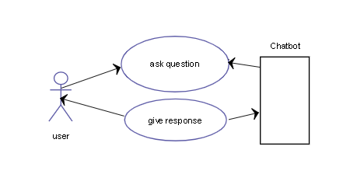Figure. 3.1 Use case Diagram

3.3.2 ARCHITECTURE DIAGRAM
This Architecture Diagram explains how the user interacts with the customer segmentation and gets the output based on the input. The following figure 3.2 represents the overall architecture diagram.

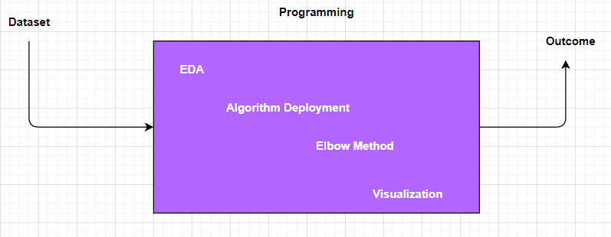
Figure. 3.2 Architecture Diagram

3.5 IMPLEMENTATION
In the implementation we can see implementation’ s made in this project. The following figures represents the implementation.
import numpy as np
import pandas as pd
import matplotlib.pyplot as plt
import seaborn as sns
df=pd.read_csv("Mall_Customers_dataset.csv")
df.head()
df.rename(columns={'Genre':'Gender'},inplace=True)
df.head()
display(df)
df.shape
df.describe()
df.dtypes
df.drop(["CustomerID"],axis=1,inplace=True)
df.head()
plt.figure(1, figsize=(15,6))
n=0
for x in ['Age' , 'Annual Income (k$)' , 'Spending Score (1-100)']:
n += 1
plt.subplot(1 , 3 , n)
plt.subplots_adjust(hspace =0.5 , wspace = 0.5)
sns.distplot(df[x] , bins = 20)
plt.title('Distplot of {}'.format (x))
plt.show()
plt.figure(figsize=(15,5))
sns.countplot(y='Gender',data=df)
plt.show()

plt.figure(1,figsize=(15,7))
n=0
for cols in ['Age','Annual Income (k$)','Spending Score (1-100)']:
n+=1
plt.subplot(1 , 3 , n)
sns.set(style="whitegrid")
plt.subplots_adjust(hspace = 0.5,wspace = 0.5)
sns.violinplot(x = cols,y = 'Gender', data = df)
plt.ylabel('Gender' if n == 1 else '')
plt.title('Violin Plot')
plt.show()
age_18_25 = df.Age[(df.Age >= 18) & (df.Age <= 25)]
age_26_35 = df.Age[(df.Age >= 26) & (df.Age <= 35)]
age_36_45 = df.Age[(df.Age >= 36) & (df.Age <= 45)]
age_46_55 = df.Age[(df.Age >= 46) & (df.Age <= 55)]
age_55above = df.Age[df.Age >= 56]

agex = ["18-25","26-35","36-45","46-55","55+"]
agey = [len(age_18_25.values),len(age_26_35.values),len(age_36_45.values),len(age_46_55.values),len(age_55above.values)]

plt.figure(figsize=(15,6))
sns.barplot(x=agex,y=agey,palette="mako")
plt.title("Number of Customer and Ages")
plt.xlabel("Age")
plt.ylabel("Number of Customer")
plt.show()
sns.relplot(x="Annual Income (k$)",y="Spending Score (1-100)",data=df)
ss_1_20 = df["Spending Score (1-100)"] [(df["Spending Score (1-100)"] >= 1) & (df["Spending Score (1-100)"] <= 20)]
ss_21_40 = df["Spending Score (1-100)"][(df["Spending Score (1-100)"] >= 21) & (df["Spending Score (1-100)"] <= 40)]
ss_41_60 = df["Spending Score (1-100)"][(df["Spending Score (1-100)"] >= 41) & (df["Spending Score (1-100)"] <= 60)]
ss_61_80 = df["Spending Score (1-100)"][(df["Spending Score (1-100)"] >= 61) & (df["Spending Score (1-100)"] <= 80)]
ss_81_100 = df["Spending Score (1-100)"][(df["Spending Score (1-100)"] >= 81) & (df["Spending Score (1-100)"] <= 100)]

ssx = ["1-20", "21-40", "41-60", "61-80", "81-100"]
ssy = [len(ss_1_20.values),len(ss_21_40.values),len(ss_41_60.values),len(ss_61_80.values),len(ss_81_100.values)]

plt.figure(figsize=(15,6))
sns.barplot(x=ssx,y=agey,palette="rocket")
plt.title("Spending Scores")
plt.xlabel("Score")
plt.ylabel("Number of Customer Having the Score")
plt.show()

ai0_30 = df["Annual Income (k$)"][(df["Annual Income (k$)"] >= 0) & (df["Annual Income (k$)"] <= 30)]
ai31_60 = df["Annual Income (k$)"][(df["Annual Income (k$)"] >= 31) & (df["Annual Income (k$)"] <= 60)]
ai61_90 = df["Annual Income (k$)"][(df["Annual Income (k$)"] >= 61) & (df["Annual Income (k$)"] <= 90)]
ai91_120 = df["Annual Income (k$)"][(df["Annual Income (k$)"] >= 91) & (df["Annual Income (k$)"] <= 120)]
ai121_150 = df["Annual Income (k$)"][(df["Annual Income (k$)"] >= 121) & (df["Annual Income (k$)"] <= 150)]

aix = ["$ 0 - 30,000", "$ 30,001 - 60,000", "$ 60,001 - 90,000", "$ 90,001 - 120,000", "$ 120,001 - 150,000"]
aiy = [len(ai0_30.values),len(ai31_60.values),len(ai61_90.values),len(ai91_120.values),len(ai121_150.values)]

plt.figure(figsize=(15,6))
sns.barplot(x=aix,y=aiy,palette="Spectral")
plt.title("Annual Incomes")
plt.xlabel("Income")
plt.ylabel("Number of Customer")
plt.show()
X1=df.loc[:, ["Age","Spending Score (1-100)"]].values

from sklearn.cluster import KMeans
wcss = []
for k in range(1,11):
kmeans = KMeans(n_clusters=k, init="k-means++")
kmeans.fit(X1)
wcss.append(kmeans.inertia_)
plt.figure(figsize=(12,6))
plt.grid()
plt.plot(range(1,11),wcss, linewidth=2, color="red", marker ="8")
plt.xlabel("K Value")
plt.ylabel("WCSS")
plt.show()
kmeans = KMeans(n_clusters=4)

label = kmeans.fit_predict(X1)

print(label)

print(kmeans.cluster_centers_)
plt.scatter(X1[:,0], X1[:,1], c=kmeans.labels_, cmap='rainbow')
plt.scatter(kmeans.cluster_centers_[:,0] ,kmeans.cluster_centers_[:,1], color='black')
plt.title('Clusters of Customers')
plt.xlabel('Age')
plt.ylabel('Spending Score(1-100)')
plt.show()
X2=df.loc[:, ["Age","Spending Score (1-100)"]].values

from sklearn.cluster import KMeans
wcss = []
for k in range(1,11):
kmeans = KMeans(n_clusters=k, init="k-means++")
kmeans.fit(X2)
wcss.append(kmeans.inertia_)
plt.figure(figsize=(12,6))
plt.grid()
plt.plot(range(1,11),wcss, linewidth=2, color="red", marker ="8")
plt.xlabel("K Value")
plt.ylabel("WCSS")
plt.show()
kmeans = KMeans(n_clusters=5)

label = kmeans.fit_predict(X2)

print(label)
print(kmeans.cluster_centers_)
plt.scatter(X2[:,0], X1[:,1], c=kmeans.labels_, cmap='rainbow')
plt.scatter(kmeans.cluster_centers_[:,0] ,kmeans.cluster_centers_[:,1], color='black')
plt.title('Clusters of Customers')
plt.xlabel('Annual Income (k$)')
plt.ylabel('Spending Score(1-100)')
plt.show()
X3=df.iloc[:,1:]

wcss = []
for k in range(1,11):
kmeans = KMeans(n_clusters=k, init="k-means++")
kmeans.fit(X3)
wcss.append(kmeans.inertia_)
plt.figure(figsize=(12,6))
plt.grid()
plt.plot(range(1,11),wcss, linewidth=2, color="red", marker ="8")
plt.xlabel("K Value")
plt.ylabel("WCSS")
kmeans = KMeans(n_clusters = 5)

label = kmeans.fit_predict(X3)

print(label)
print(kmeans.cluster_centers_)
clusters = kmeans.fit_predict(X3)
df["label"] = clusters

from mpl_toolkits.mplot3d import Axes3D

fig = plt.figure(figsize=(20,10))
ax = fig.add_subplot(111, projection='3d')
ax.scatter(df.Age[df.label == 0],df["Annual Income (k$)"][df.label == 0], df["Spending Score (1-100)"][df.label == 0], c='blue', s=60)
ax.scatter(df.Age[df.label == 1],df["Annual Income (k$)"][df.label == 1], df["Spending Score (1-100)"][df.label == 1], c='red', s=60)
ax.scatter(df.Age[df.label == 2],df["Annual Income (k$)"][df.label == 2], df["Spending Score (1-100)"][df.label == 2], c='green', s=60)
ax.scatter(df.Age[df.label == 3],df["Annual Income (k$)"][df.label == 3], df["Spending Score (1-100)"][df.label == 3], c='orange', s=60)
ax.scatter(df.Age[df.label == 4],df["Annual Income (k$)"][df.label == 4], df["Spending Score (1-100)"][df.label == 4], c='purple', s=60)
ax.view_init(30,185)

plt.xlabel("Age")
plt.ylabel("Annual Income (k$)")
ax.set_zlabel('Spending Score (1-100)')

plt.show()

Figure 3.8 Implementation of modules

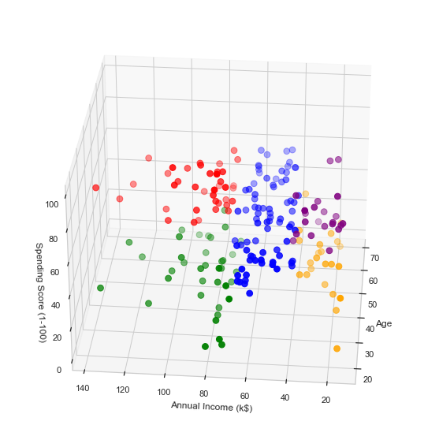

Figure 3.9
3.6 TESTING
In the testing part first the source code is tested to check whether the code executes the excepted output. Then the Functionality of the project is tested to check the excepted output is obtained. Then the interface of the project is tested to check the interface works properly. Then the modules are tested separately to check whether the excepted output is obtained. Testing is a process of executing a program with the intent of finding an error. The objective of software testing is to uncover errors. Software testing, depending on the testing method employed, can be implemented at any time in the development process, however most of the effort is employed after the requirements have been defined and coding process has been completed. Testing is usually performed for the following purposes:
- To improve quality
- For verification and validation
- For reliability estimation

3.6.1 TYPES OF TESTING
- Functional Testing
- Integration Testing
- Source code Testing
- Module Level Testing

FUNCTIONAL TESTING
Functional testing is mainly used as a Quality Assurance process. This is a very simple process where each function is provided with an appropriate input and is verified against an expected output and with boundary values. This would help in ensuring that the output is as acquired according to the expectations and would help assuring the quality.

INTEGRATION TESTING
It is a systematic technique for constructing the program structure while at the same time conducting tests to uncover errors associated with in the interface. Integration of all the components to form the entire system and an overall testing is executed. Integration testing is any type of software testing that seeks to verify the interfaces between components against a software design. Software components may be integrated in an iterative way or all together as in a on the whole approach. It is mainly done based on by taking into account of the number of modules used, how many number of interfaces maybe required to integrate them, which had to be combined and clustering process.

SOURCE CODE TESTING
This examines the logic of the system. If we are getting the output that is required by the user, then we can say that the logic is perfect.

MODULE LEVEL TESTING
In this the error will be found at each individual module. It, encourages the programmer to find and rectify the errors without affecting the other modules.

  - MODULES
3.8.1 Pyttsx3
Pyttsx3 is a text-to-speech conversion library in Python. Unlike alternative libraries, it works offline and is compatible with both Python 2 and 3. An application invokes the pyttsx3.init() factory function to get a reference to a pyttsx3. Engine instance. it is a very easy to use tool which converts the entered text into speech.
The pyttsx3 module supports two voices first is female and the second is male which is provided by “sapi5” for windows.
It supports three TTS engines
- sapi5 – SAPI5 on Windows
- nsss – NSSpeechSynthesizer on Mac OS X
- espeak – eSpeak on every other platform

Example:
# Import the required module for text
# to speech conversion
import pyttsx3

# init function to get an engine instance for the speech synthesis
engine = pyttsx3.init()

# say method on the engine that passing input text to be spoken
engine.say('Hello sir, how may I help you, sir.')

# run and wait method, it processes the voice commands.
engine.runAndWait()

3.8.2 SPEECH RECOGNITION
    - PYAUDIO
PyAudio provides Python bindings for PortAudio, the cross-platform audio I/O library. With PyAudio, you can easily use Python to play and record audio on a variety of platforms. PyAudio is inspired by: tkSnack: cross-platform sound toolkit for Tcl/Tk and Python.

3.8.4 DICTIONARY

3.8.5 TKINTER
Tkinter is the standard GUI library for Python. Python when combined with Tkinter provides a fast and easy way to create GUI applications. Tkinter provides a powerful object-oriented interface to the Tk GUI toolkit.
Creating a GUI application using Tkinter is an easy task. All you need to do is perform the following steps −
- Import the Tkinter module.
- Create the GUI application main window.
- Add one or more of the above-mentioned widgets to the GUI application.
- Enter the main event loop to take action against each event triggered by the user.
Example:
#!/usr/bin/python
import Tkinter
top = Tkinter.Tk()
# Code to add widgets will go here...
top.mainloop()

CHAPTER 4

RESULT AND DISCUSSION

Chapter 3 discussed about the requirements analysis, overall design of the project and implementation. This chapter discusses about the conclusion and future enhancements.

4.1 RESULTS
The result of the project “CUSTOMER SEGMENTATION USING K-MEAN, DENSITY AND CENTROID BASED CLUSTERING IN MACHINE LEARNING” is obtained as expected. This project is implemented using k-mean algorithm. By representing 3D graph, customer segmentation is done by clustering our customer data based on various variables like exploratory data analysis, gender plot analysis, age plot, annual income vs spending score and elbow method.

4.2 DISCUSSION
This whole system deals with the exploratory data analysis, gender plot analysis, age plot, annual income vs spending score, elbow method and by representing 3D graph. The following figures represents the outputs.

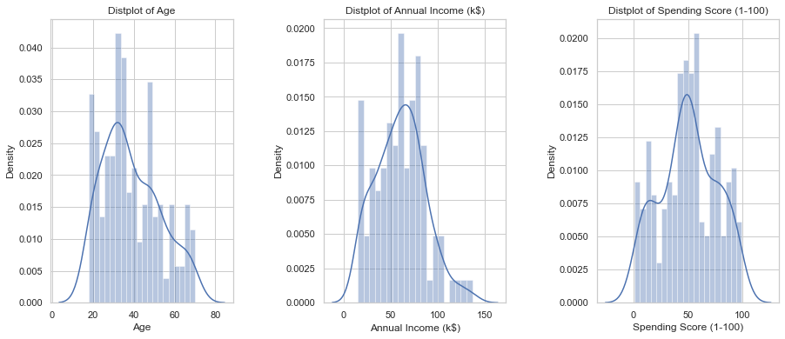

Figure 4.1

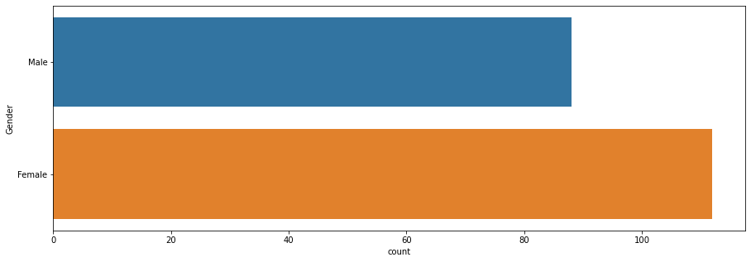

Figure 4.2

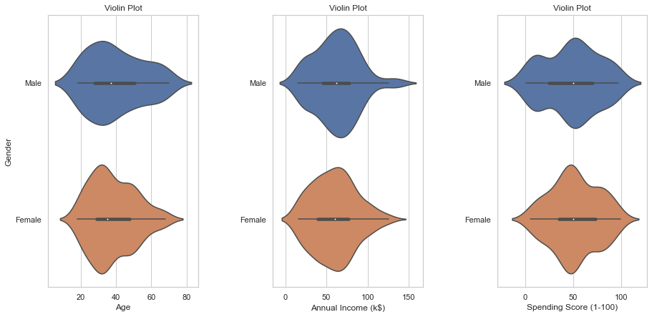

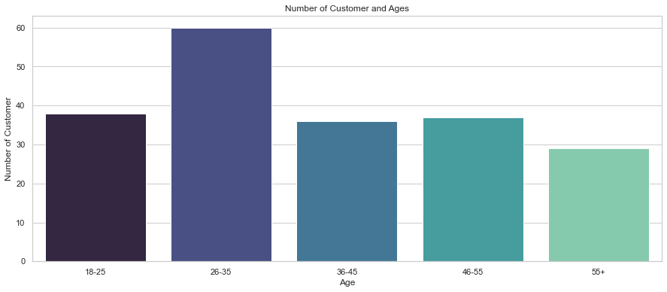
Figure 4.4

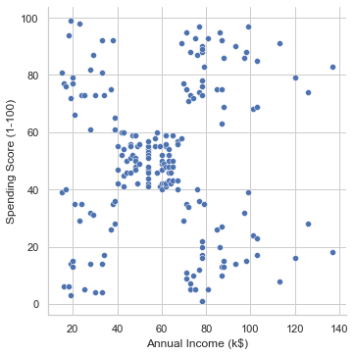
Figure 4.5

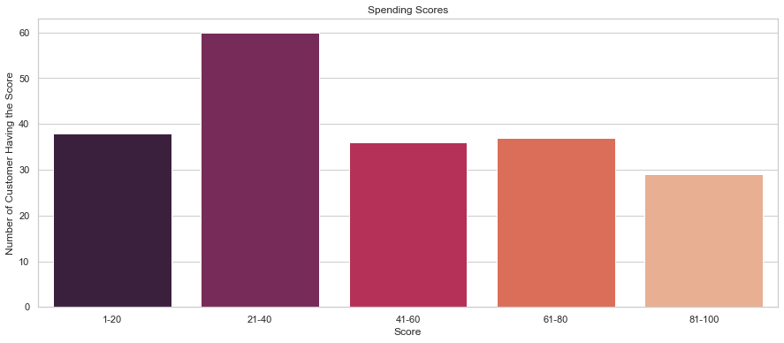

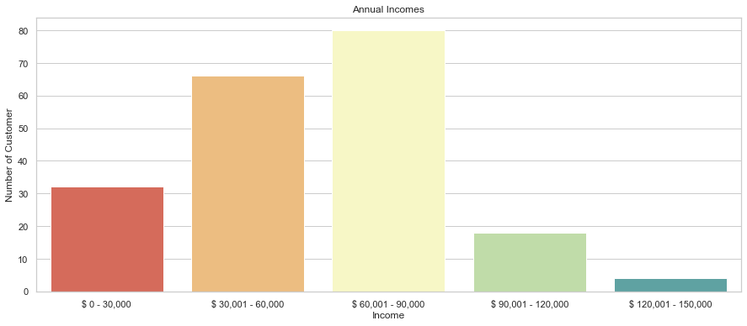

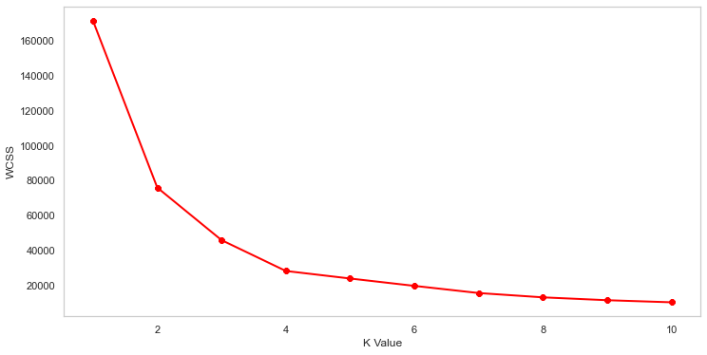

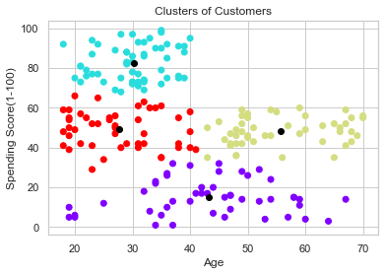

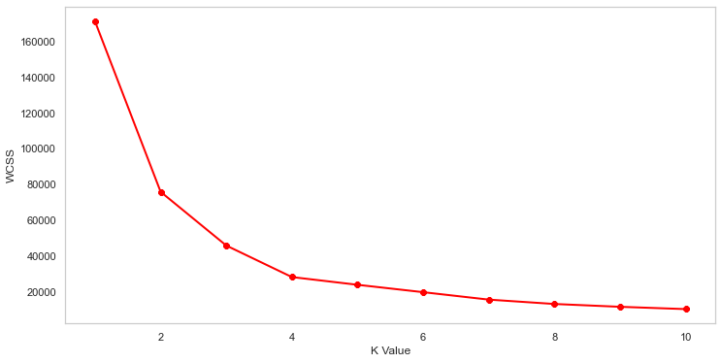

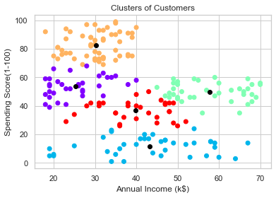
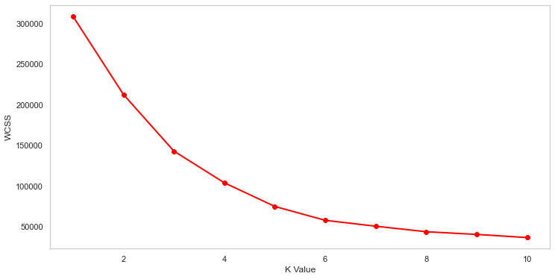

CHAPTER 5

CONCLUSION AND FUTURE ENHANCEMENT

  - CONCLUSION
So we concluded that the,
- The Highest income , high spending can be target these type of customers as they earn more money and spend as much as they want.
- Highest income, low spending can be target these type of customers by asking feedback and advertising the product in a better way.
- Average income, Average spending may or may not be beneficial to the mall owners of this type of customers.
- Low income, High spending can be target these type of customers by providing them with low-cost EMI’s etc.
- Low income, Low spending don’t target these type of customers because they earn a bit and spend some amount of money.
So high income, high spending are the most beneficial ones to the mall owners which increases the owner’s business. (Cluster 1).

5.2 FUTURE WORK
The proposed basic cluster model given the lack of details about the changes in customer behaviours. Therefore different rules and strategies are necessary to find the hidden patterns and shopping trends of the customers. K-means helped to find clusters of potential customers. In addition to this Cross Selling and Market Basket Analysis techniques can be used to analyse and offer additional products to customers as a suggestion in the hope that they would buy benefiting the customer and the retail establishment.

APPENDIX

SAMPLE SOURCE CODE

import tkinter as tk
from tkinter.constants import CENTER, COMMAND
from PIL import Image, ImageTk
from tkinter.filedialog import askopenfile
import time
import random
from PyDictionary import PyDictionary
import speech_recognition as sr
import pyttsx3
from playsound import playsound
import pyaudio
root = tk. Tk()
root.resizable(True,True)
listener=sr.Recognizer()
engine=pyttsx3.init()
voices=engine.getProperty('voices')
engine.setProperty('voice',voices[1].id)
dict = PyDictionary()
def talk(text):
textoutputed(text)
rate=130
engine.setProperty('rate',rate)
engine.say(text)
engine.runAndWait()
def take_command(a):
try:
with sr.Microphone() as source:
print("input")
listener.pause_threshold = 1
voice = listener.listen(source,timeout=a,phrase_time_limit=a)
print("end")
command=listener.recognize_google(voice)
command=command.lower()
textdetected(command)
print(command)
return command
except:
talk("cant hear you, say again")
return take_command(a)
def meanin(key):
x=(dict.meaning(key))
talk("you want verb or adjective or noun")
s=take_command(4)
if "verb" in s:
try:
z=x.get('Verb')
a=random.randrange(0,len(z))
print (z[a])
talk(z[a])
return 0
except:
talk("verb is not availble for "+key)
elif "adjective" in s:
try:
z=x.get('Adjective')
a=random.randrange(0,len(z))
print (z[a])
talk(z[a])
return 0
except:
talk("adjective is not availble for "+key)
elif "noun" in s:
try:
z=x.get('Noun')
a=random.randrange(0,len(z))
print (z[a])
talk(z[a])
return 0
except:
talk("Noun is not availble for "+key)
else:
talk("command unrecohinized")
meanin(key)
def syno(key):
try:
z=dict.synonym(key)
a=random.randrange(0,len(z))
print (z[a])
talk(z[a])
return 0
except:
talk("no synonym available")
def anto(key):
try:
z=dict.antonym(key)
a=random.randrange(0,len(z))
print (z[a])
talk(z[a])
return 0
except:
talk("no antonym available")
def pron(key):
b=""
for i in key:
if i==" ":
None
#print("space")
else:
b=b+i
talk(b)
print(b)
return 0
def rhymes():
playsound("WheelsOn-the-Bus.mp3")
def start():
talk("what u want me to do say meaning antonym pronounciation or rhymes ")
choice=take_command(4)
choice=choice.split()

REFERENCES
- Kumar, M Naveen, PC Linga Chandar, A Venkatesh Prasad, and K Sumangali (2016). Android based educational Chatbot for visually impaired people. In: International Conference on Computational Intelligence and Computing Research (ICCIC), 2016 IEEE. IEEE, pp. 1–4.
- Ranoliya, Bhavika R, Nidhi Raghuwanshi, and Sanjay Singh (2017). Chatbot for University Related FAQs. In: 2017 International Conference on Advances in Computing, Communications and Informatics (ICACCI). Udupi, pp. 1525–1530.
- Lue Lin, Luis Fdo. D’Haro, and Rafael Banchs. A Webbased Platform for Collection of Human Chatbot Interactions, Paper accepted in HAI 2016 to appear in Oct. 2016.
- Emanuela Haller and Traian Rebedea, Designing a Chatbot that Simulates an Historical Figure, IEEE Conference Publications, July 2013.
- Maria das Graças Bruno Marietto, Rafael Varago de Aguiar, Gislene de Oliveira Barbosa, Wagner Tanaka Botelho, Edson Pimentel, Robson dos Santos França, and Vera Lúcia da Silva, Artificial Intelligence Markup Language: A Brief Tutorial, International Journal of Computer science and engineering Survey (IJCSES), July 2013.
- N. Thomas, e-business chatbot using aiml and lsa, in Advances in Computing, Communications and Informatics (ICACCI), 2016 International Conference on. IEEE, 2016, pp. 2740–2742.
- Mikic, Fernando A, Juan C Burguillo, Mart´ın Llamas, Daniel A Rodr´ıguez, and Eduardo Rodr´ıguez (2009). Charlie: An aiml-based chatterbot which works as an interface among ines and humans. In: EAEEIE Annual Conference, 2009. IEEE.
- Deryugina, OV (2010). Chatterbots. In: Scientific and Technical Information Processing 37.2, pp. 143–147.
- Wallace, Richard S. The anatomy of Alice. Parsing the Turing Test. Springer Netherlands, 2009. 181-210.
- Steven Bird, Ewan Klein, and Edward Loper – Natural Language Processing with Python, Published by: O’Reilly Media, Inc., June 2009.

TECHNICAL BIOGRAPHY
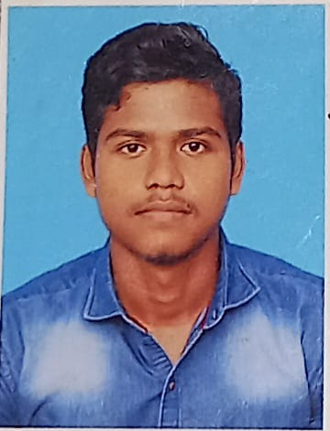

ANWAR HAMEED G (RRN: 191421601004) was born on 20th April 2001, in Chennai, Tamil Nadu. He did his schooling in Kendriya Vidyalaya Matriculation Hr. Sec. School, Meenambakam and he secured 7.5% in the Higher Secondary Examination. Currently pursuing Bachelor of Computer Applications Degree program in B. S. Abdur Rahman University, Vandalur, Chennai-600048.
E-mail ID: anwarhameed2001@gmail.com
Phone: +91 8925475179
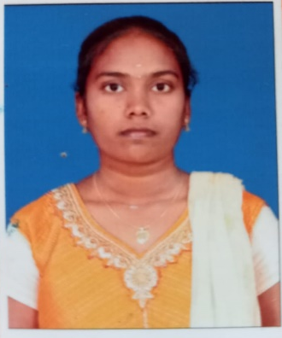

NATHIPRIYA V (RRN: 191421601036) was born on 20th January 2001, in Guduvanchery, Tamil Nadu. She did her schooling in St. Mary’s Matriculation Hr. Sec. School, Guduvanchery and he secured 57% in the Higher Secondary Examination. Currently pursuing Bachelor of Computer Applications Degree program in B. S. Abdur Rahman University, Vandalur, Chennai-600048.
E-mail ID: jagadishgowtham0@gmail.com
Phone : +91 6382948893

